


Movie Recommendation – CPIT 440

With Deep Respect, Submitted to Dr. Mahmoud
Department of Information Technology
At King Abdulaziz University (KAU)

Phase 1 - Proposal Description
Muath Abbas Eissa [2338818]
Meshal Ahmad AlAjlani [2335521]
Hashim Yaser Bajaber [2336321]
Mohammed Khalid Alahmadi [2340345]

Date of Submission
6th December 2025

Contents
Introduction Error! Bookmark not defined.
Problem Goal Error! Bookmark not defined.
Data Mining Formalization Error! Bookmark not defined.
Data 4
Type of Data 4
Splits (Train-Test) 4
Source of Data 4
Dataset Description 5
Representation of Missing Values 5
Categorical Attributes and Categories Error! Bookmark not defined.
Visualization 5
Histogram - Rating Distribution 5
Boxplot: Release Year 6
Scatter Plot: Runtime vs Rating 6
Correlation Study 6
Related Paper 7
Paper Title and Authors Error! Bookmark not defined.
Used Models Error! Bookmark not defined.
Which model was better? Error! Bookmark not defined.
Summary Error! Bookmark not defined.

Introduction
This project focuses on developing a movie recommendation system that identifies meaningful patterns in movie data and groups similar movies together using clustering techniques. The system applies the K-Means clustering algorithm to analyze key movie attributes, particularly genre information along with numerical factors such as rating and runtime.
By grouping movies based on shared characteristics, the system can better understand similarity patterns and provide relevant recommendations to users based on the cluster each movie belongs to.

Problem Goal
The goal of this project is to build a recommendation system that predicts what movies a user may enjoy by examining similarities between movies. The model identifies movies that share similar genres and numerical characteristics and uses this information to generate suggestions.
The expected outcome is a model that uses K-Means clustering to form meaningful groups of similar movies. Recommendations are then generated by selecting movies from the same cluster as the user’s chosen film.

Data Mining Formalization
This project is formalized as a clustering task.
K-Means clustering is used to group movies based on a combination of content-based attributes and numerical features. Since machine learning algorithms cannot directly interpret text, the genre information (main genre and side genre) is converted into numerical vectors using CountVectorizer. This allows the algorithm to measure similarities between movies based on their genre descriptions.
In addition to genre vectors, numerical attributes such as rating and runtime are included directly in the feature set. Together, these features allow the model to cluster movies based on both content similarities and quantitative differences.

Data

Type of Data
The dataset contains movie metadata, including:
- Movie title
- Year
- Director
- Actors
- Rating
- Runtime (in minutes)
- Censorship classification
- Total gross
- Main genre
- Side genre

For this project, the clustering model specifically uses:
- Main Genre
- Side Genre
- Rating
- Runtime(Mins)
These attributes were selected because they play the biggest role in defining similarity between movies.
The dataset includes both numerical attributes (such as rating and runtime) and categorical/textual attributes (such as genres).

Splits (Train-Test)
The clustering model (K-Means) does not require a train-test split. EDA visuals and preprocessing are applied to the full dataset before fitting the clustering model.

Source of Data
The dataset is:
IMDB_All_Genres_etf_clean1.csv, an IMDb-based movie dataset containing 5562 rows and 10 attributes.

Dataset Description
The dataset was successfully loaded and inspected:
- First 5 rows and last 5 rows were printed to confirm structure.
- Total columns: 10
- Total rows: 5562

Representation of Missing Values
The dataset does not use numpy.nan, "unknown", or "?" as missing values — all entries are complete.
- Numerical: Year, Rating, Runtime
- Categorical: Movie_Title, Director, Actors, Censor, Total_Gross, main_genre, side_genre

Visualization

Histogram - Rating Distribution
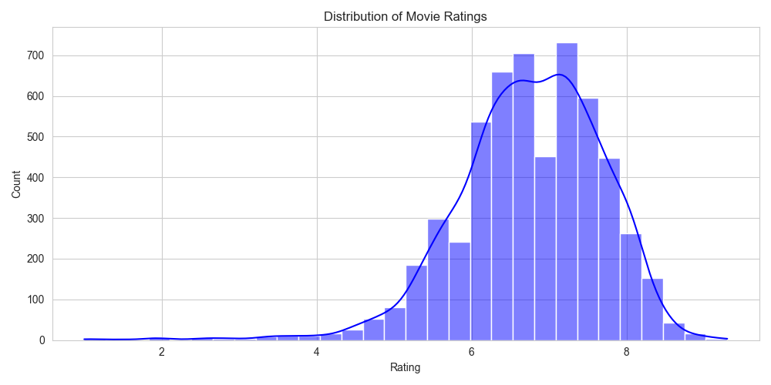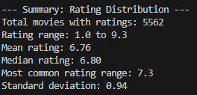

Boxplot: Release Year
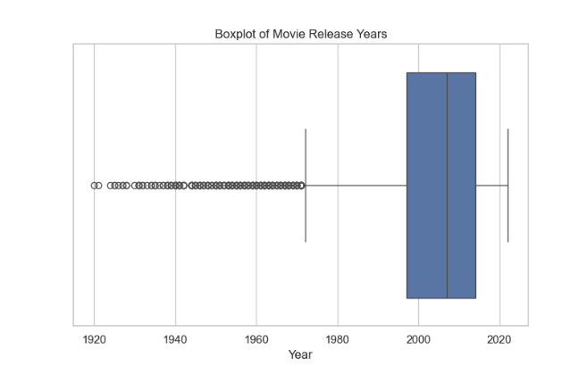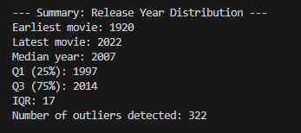

Scatter Plot: Runtime vs Rating
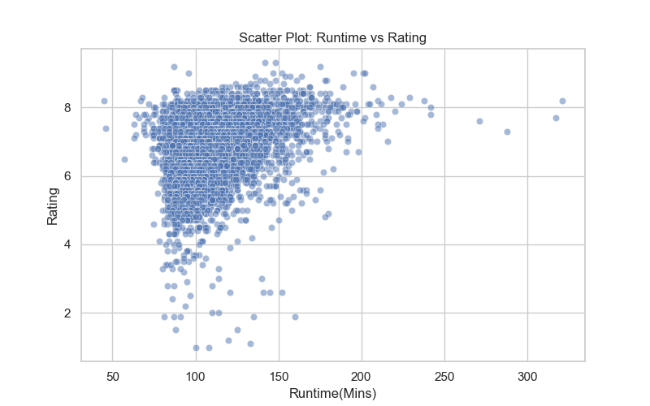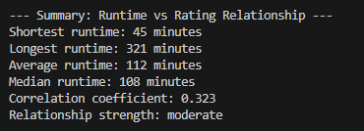

Correlation Study
A correlation matrix was generated using numerical attributes.
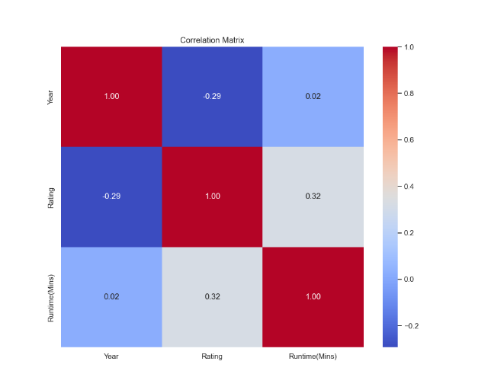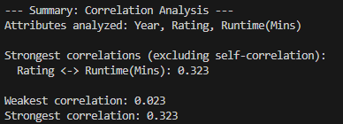

Related Paper
Paper Title and Authors
Paper Title: Movie Recommendation with K-Means Clustering and Self-Organizing Map Methods
Authors: Eugene Seo and Ho-Jin Choi

Used Models
The paper presents a movie recommendation approach based on clustering. It examines two unsupervised machine learning models: K-Means Clustering and Self-Organizing Maps (SOM). Both models are used to group similar items so that the system can generate more meaningful recommendations. K-Means focuses on providing fast and efficient grouping, while SOM forms more detailed clusters but requires higher computational cost.

Which Model Was Better?
The study found that SOM produced slightly more accurate clusters due to its ability to capture complex patterns. However, K-Means was significantly faster and more practical for large datasets. The authors concluded that K-Means offers the best balance between accuracy and efficiency, making it a suitable choice for real-world recommendation systems.

Summary
In our project, we explored the movie dataset, analyzed key attributes, and applied K-Means clustering to group similar films based on their main and side genres, along with important numerical features such as rating and runtime. By converting genre information into numerical form and combining it with scaled numeric attributes, the model is able to identify meaningful similarity patterns between films.
This clustering step provides a strong foundation for developing a content-based movie recommendation system, where similar films can be suggested to users based on the cluster in which each movie is placed.

